Ten Prophetic Clues Concerning
Benjamin – (Western) Vikings

Benjamin did not belong to the Ten Tribes. However, part of the tribe of Benjamin ended up in the north. Bethel and Jericho i.e., were no longer towns in Judah, but they had become towns in the Kingdom of Israel. The tribal area of Benjamin was a buffer area between the House of Israel and the House of Judah. People tended to stay in their cities and homes and thus a number of the Benjamites were taken along into the Assyrian captivity of the Ten Tribes. There is no direct history connecting the tribe of Benjamin to the (Western) Vikings. We are talking about the lost tribes. Even the Caucasian population of Denmark and Norway comes from various backgrounds. One can compare this to Jewry. The Jewish people have known many proselytes, yet, there has been a core of the tribe of Judah (and some of Levi & Benjamin) over the past 2500 years. The core passes on characteristics and genes to the periphery. Looking at the ‘prophetic clues’, one may conclude, that a core of the tribe of Benjamin once found its way to Scandinavia. This core passed on its characteristics and genes to the influx of others. The more fulfilled prophetic clues we find, the stronger our case. In this article we will deal with the Western Vikings, the ancestors of Danes, Norwegians and Icelanders. To my understanding the Swedes are mainly from Naphtali. What follows is not historic proof, but proof by revelation.

Benjamites:
Saul – First king of Israel. Fought 40 years successfully against the neighbouring nations, especially against the Philistines. Lost God’s favour. Went to the witch of Endor. Died on the hills of Gilboa with his sons Jonathan, Abinadab and Malchishua (1Sam 9-31)
Jonathan – Hero and successor to the throne. Loved David, with whom he made a covenant. They would look after each others children (1Sam 20).
Abner – Saul’s cousin. Army commander of Saul and of Ishbosheth. Fought a hopeless civil war with Joab for some years. Abner had killed Joab’s brother with a single backwards thrust of his spear. Joab murdered Abner when he had come to surrender the northern tribes into David’s hands (1 Sam 14 – 2 Sam 3).
Ishbosheth – Son of Saul. Abner put Ishbosheth on the throne in Mahanaim (is in the tribal area of Gad). He was a puppet of Abner. Ishbosheth blamed Abner for taking Rizpah, his father’s concubine. The angry Abner decided to end the civl war and to deliver the north into the hands of David (2Sam 2-4).
Mephibosheth – Cripple son of Jonathan. Because of Jonathan’s covenant with David, Mephibosheth got a place at David’s court (2Sam 9, 16, 19)
Baanah and Rechab – Two leaders of warrior bands for Ishbosheth, during the civil war. They killed their king Ishbosheth and cut off his head to take it to David. Instead of receiving a reward, they were executed (2Sam 4).
Shimei – During Absalom’s rebellion Shimei expected a reinstating of the House of Saul. So during David’s flight, Shimei walked along with king David, cursing and throwing stones (2 Sam 16, 19).
Sheba – Sheba called for a rebellion of the tribes against David. He fled to Abel of Bethmaachah, but the inhabitants chucked his head over the wall to Joab, David’s general (2 Sam 20).
Esther & Mordecai – Jews of the tribe of Benjamin at the time of the Persians. They saved the Jewish people (Judah) in a valiant way (Book of Esther).
Paul – At first Saul persecuted the Church with the sword; later as Paul he preached the cross and wrote 1Corinthians 13, an Ode to Love (NT).

1st Clue: Benjamin: Joseph’s full brother

The sons of Rachel; JOSEPH, AND BENJAMIN (Gen 35:24).
But BENJAMIN, JOSEPH’S [FULL] BROTHER, Jacob sent not with his brethren; for he said, Lest peradventure mischief befall him (Gen 42:4).
And [Joseph] fell upon his brother Benjamin’s neck, and wept; and Benjamin wept upon his neck (Gen 45:14, AV throughout, unless mentioned otherwise).

Joseph & Benjamin

There was a close tie between Joseph and Benjamin. All the other brothers were half-brothers to Joseph, but Benjamin was his only full brother. In Eretz Yisrael their tribal areas formed a whole. Benjamin lived south of Ephraim and Manasseh.
In the time of the judges the tribe of Benjamin was extinguished, all but for 600 men. 200 of those 600 got their wives from the daughters of Shiloh, so of the tribe of Ephraim. Rachel genes of the tribe of Ephraim (Joseph) were added to the tribe of Benjamin.

Vikings in the British Isles

During the Viking Age many Vikings settled in the British Isles. Many Britons have some Viking blood. The Danes mainly settled in the Danelaw (East England). Vikings from Norway circled the whole and came from the north and settled in Scotland, Ireland (Dublin), Wales and the Isle of Man. Benjamin embraced Joseph in the Bible and in a sense Benjamin embraced Joseph on the map and mixed with Joseph.

Linguistic Loans

No wonder that the English language has many Old Norse loans: anger, awe, are, berserk, call, cast, egg, fellow, fog, gap, get, gun, happy, husband, ill, kid, kindle, knife, knot, law, leg, loft, low, mire, muck, odd, outlaw, wrong, wing, window, whirl, weak, until, ugly, trust, till, tidings, thwart, thrust, thrift, though, their, teem, take, sway, sick, etc.

2nd Clue: Benjamin: … in the west …

ON THE WEST SIDE [of the Tabernacle] shall be the standard of the camp of EPHRAIM [son of Joseph] according to their armies … And by him shall be the tribe of MANASSEH [son of Joseph] … Then the tribe of BENJAMIN …(Num 2:18-24).
The Tabernacle

There are three Rachel tribes: Ephraim, Manasseh and Benjamin. The Rachel tribes camped west of the Tabernacle, under Ephraim’s leadership. I believe that the western Vikings (from Denmark and Norway) are descendants of Benjamin and ended up in Denmark, Norway, Iceland and the Faeroe Islands. Ephraim and Manasseh ended up in the British Isles, all three far to the west.
Quite a few Vikings settled in the British Isles. Many Danes settled in Normandy, which got its name from the Norsemen. Many of these Normans (with Viking blood) crossed the Channel with William the Conqueror (1066) and settled in the British Isles too. So, in the Viking Age many Vikings went west.

Norse Vikings

About 500 years before Columbus (1492) and the English (1497), the Norse Vikings arrived in America. The Norse Vikings sailed their ships westwards to Iceland, Greenland and Vinland (New Foundland, Canada). The Viking colony in Greenland survived for about 450 to 500 years. The Viking Benjamites were the first in the New World and the first of the Israelites to go west. Later on to be followed by many others of the Lost Tribes.

3rd Clue: Benjamin, FIVE TIMES as much

And Joseph sent food to them from his table, but he sent FIVE TIMES as much to BENJAMIN as to any of the others. And they took wine freely with him. (Gen 43:34, BBE, Bible in Basic English).
To all of them he gave each man changes of raiment; but to Benjamin he gave three hundred pieces of silver, and FIVE CHANGES OF RAIMENT (Gen 45:22).

Five times as much

When the brothers came back to Joseph, Benjamin with them this time, they set down to eat with him. Benjamin’s portion of food was five times as much. The other brothers got a set of clothing and Benjamin got five sets of clothing. We see that the Benjamites got an extensive area of land in Europe. The Western Vikings spread out over Denmark, Skane, Norway, Iceland and Faeroe Islands. Their flags are all variations of the Danish flag. Red, white and blue are also the colours of the entrance of the tabernacle and of the high priest. These colours also feature the flags of many other Lost Tribes Nations.

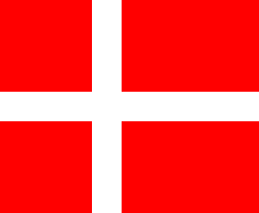
Denmark (white on red)

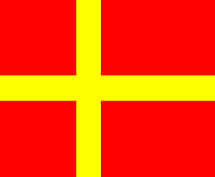
Skåne (yellow on red)

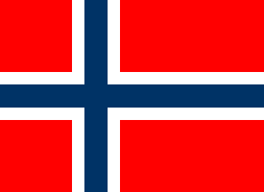
Norway (blue/white on red)

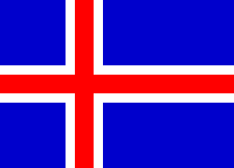
Iceland (red/white on blue)

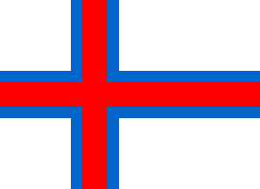
Faeroe Islands (red/blue on white)
The Danish flag is red with a white cross. The flag of Skåne (South Sweden) is a Danish flag with a yellow cross (of Sweden). The Norwegian flag is the Danish flag with a smaller blue cross in the middle. The flag of Iceland is a variation of the Norwegian flag, switching the red and blue. The Faeroe Islands show their link with Iceland and Norway by using the same clours in a different order.

4th Clue: Benjamin: a ravenous wolf

Benjamin is A RAVENOUS WOLF, in the morning devouring the prey, and at even dividing the spoil." (Gen 49:27, RSV).

Jewish Encyclopedia

The Jewish Encyclopedia states about this: “[According to the rabbis]: His comparison to the ravening wolf (Cant. R. to viii. 1), "who devours his enemy" (Gen. xlix. 27) is referred to the men of Shiloh who stole their wives (Judges xxi.) or to Ehud or to Saul. By others it is referred to Mordecai and Esther (Gen. R. xcix. and Tan., Wayeḥi, 14; so also in the original text of the Testaments of the Twelve Patriarchs [Benjamin ii]; whereas a Christian interpolation refers it to Paul).

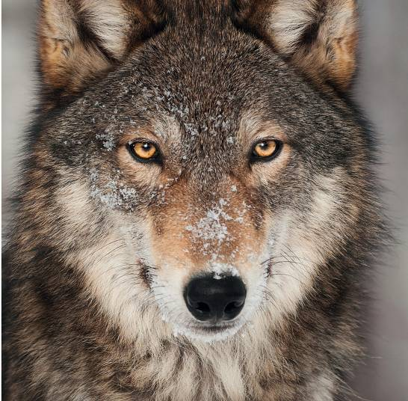

Vikings – wolves

There is no people that fulfilled this verse as the Vikings did during the three centuries of the Viking Age. In gangs they attacked early in the morning in hit-and-run style, and at evening they divided the spoil. The common sword of the time was the Ulfberht sword. Ulfberht probably was the name of a bladesmith or of a group of bladesmiths. Ulfberht translates into English as Bright Wulf.
Wikipedia: ‘Viking raid warfare’

Wikipedia: Vikings tried to gain a reputation for their first ever raids and piracy in many parts of Europe, especially England, Ireland, and Frankish territories. The term "Viking age" refers to the period roughly from 793 AD to the late 11th century in Europe. In this era Viking activity started with raids on Christian lands in England and eventually expanded to mainland Europe ... While maritime battles were rare, Viking bands proved very successful in raiding coastal towns and monasteries due to their efficient warships, and intimidating war tactics, skillful hand-to-hand combat, and fearlessness. ... Vikings' tactics in warfare gave them an enormous advantage in successfully raiding (and later colonizing), despite their small population in comparison to that of their enemies. [Compare this to Ehud and the Moabites; Jonathan against the Philistines and the tribe of Benjamin against the other 11 tribes ... few against many]. ...
In the early Viking Age, during the late 8th century and most of the 9th, Vikings consisted of smaller tribal bands with a lack of any clear central authority, governance being rooted in tribal assemblies. ...
The first known raid was on the Holy Island of Lindisfarne off the English coast in 793. This raid was also the first one that made a lasting impact on the British Isles and made the Anglo-Saxons aware of the Viking threat. ...
These raids continued for the entirety of the Viking Age. These initial raids had a religious implication to them. Vikings would target monasteries along the coast, raid the towns for their booty, and destroy what was left. This caused mass fear ...
The fast design of Viking ships was essential to their hit-and-run raids. For instance, in the sacking of Frisia in the early 9th century, Charlemagne mobilized his troops as soon as he heard of the raid, but completely missed the Vikings when he arrived. The Vikings' ships gave them an element of surprise. Often traveling in small packs, or bands, they could easily go undetected, swiftly enter a village or monastery, pillage and collect booty, and leave before reinforcements arrived.
Viking military tactics succeeded mainly because they disregarded the conventional battlefield tactics, methods, and customs of the time. They ignored the unspoken rules of leaving holy sites untouched, and they never arranged battle times. Deceit, stealth, and ruthlessness were not seen as cowardly. During raids the Vikings targeted religious sites because of their vulnerability, often butchering the clergy at these sites in honor of a Pagan god. These religious sites also contained vast amounts of wealth, which the Vikings saw as opportunities to loot and plunder. ...
Vikings attacked ships, not with the intent to destroy them, but rather to board them and take control. This is because Vikings originally based their battles around economic gains rather than political or territorial gains.

Odin & Wolves

Wikipedia: In Norse mythology, Geri and Freki (Old Norse, both meaning "the ravenous" or "greedy one") are two wolves which are said to accompany the god Odin.

5th Clue: Benjamites: fearless

And EHUD put forth his left hand, and took the dagger from his right thigh, and thrust it into his belly (Judg 3:21).
And the children of Benjamin were ... 26,000 that drew sword ... Among all this people there were 700 chosen men lefthanded ... And the men of Israel, beside Benjamin, were numbered 400,000 men that drew sword ... (Judg 20:15-17).
And JONATHAN said to his young servant who had his arms, Come, let us go over to the armies of these men who have no circumcision ... the Lord is able to give salvation by a great army OR BY A SMALL BAND (1Sam 14:6, BBE).
And all the king’s servants, that were in the king’s gate, bowed, and reverenced Haman ... But MORDECAI BOWED NOT, nor did him reverence (Esther 2:3).
But some Jews came to that place from Antioch and Iconium, and got control over the people; AND AFTER STONING PAUL, they had him pulled out of the town, taking him for dead. But when the disciples came round him, HE GOT UP AND WENT INTO THE TOWN: and the day after he went away with Barnabas ... (Acts 14:19-20, BBE).

Fearless Benjamites

Benjamites are often fearless fighters, think of Ehud, the civil war against the Benjamites (11 tribes against 1), Saul, Abner, Jonathan, Mordecai, Esther and Paul.
Left-handed Ehud went back alone and killed the Moabite king single-handedly (Judg 3). The Benjamites went to war 27,700 against 400,000, 1 tribe against 11 tribes (Judg 20). Saul, his cousin Abner, and Jonathan were great warriors. Jonathan once took an Philistine outpost together with his servant. Mordecai refused to bow for Haman. The apostle Paul was a fearless Benjamite too. After having been stoned he went back into the city of the people who had just stoned him!

Fearless Vikings

Wikipedia: Parts of the tactics and warfare of the Vikings were driven by their cultural belief, themselves rooted in Norse culture and religion, and vividly recalled in the later Icelandic sagas. In the early Viking Age, during the late 8th century and most of the 9th, Vikings consisted of smaller tribal bands with a lack of any clear central authority, governance being rooted in tribal assemblies. Rooted in honour – a vital concept in Nordic pagan tradition – violence was used as a measure to moderate disputes with other tribal groups. This emphasis on violence as a decisive tool regarding disputes was not limited to a man, but extended to his kin. Violence was seen as a measure to defend honor. Honor was extremely important to Norsemen, and the sense of shaming one's honor extended beyond physical and material injuries. Honor could be shamed from mere insults, where Norsemen were expected to react with violence often resulting in death. With this prevalence of violence came the expectation of fearlessness.
Norsemen believed that the time of death for any individual is predetermined, but that nothing else in life is. Considering this, Norsemen believed there to be two possibilities in life: "success with its attendant fame; or death." The necessity of defending honor with violence, the belief that time of death was preordained, adventure and fearlessness were core values to the Viking Age. These principal values and convictions were displayed in the tactics of Viking raids and warfare.

Amundsen, Thor Heyerdahl

Fearlessness can also be found back in the polar explorer Roald Amundsen (reached the South Pole, 1911). Adventurer and scientist Thor Heyerdahl became world famous for his Kon-tiki and Ra expeditions. Both men were from Norway, descendants of the Vikings.

Fearless Danes & Danish Jews

Wikipedia: The rescue of the Danish Jews occurred during Nazi Germany's occupation of Denmark during World War II. On October 1, 1943, Nazi leader Adolf Hitler ordered Danish Jews to be arrested and deported. The Danish resistance movement, with the assistance of many Danish citizens, managed to evacuate 7,220 of Denmark's 7,800 Jews, plus 686 non-Jewish spouses, by sea to nearby neutral Sweden. The rescue allowed the vast majority of Denmark's Jewish population to avoid capture by the Nazis and is considered to be one of the largest actions of collective resistance to aggression in the countries occupied by Nazi Germany.

6th Clue: Benjamin: sword / violence

Therefore, my children, I tell you, flee the malice of Beliar; for he giveth A SWORD to them that obey him. And THE SWORD is the mother of seven evils ... and first there is BLOODSHED; secondly, RUIN; thirdly, TRIBULATION; fourthly, EXILE; fifthly, DEARTH; sixthly, PANIC; seventhly, DESTRUCTION (Test. of Benjamin 7:1-2).
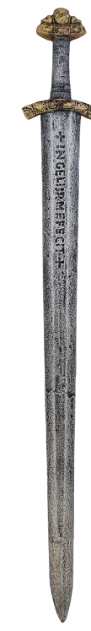
So Ehud made himself A TWO-EDGED SWORD ... 21 And Ehud put out HIS LEFT HAND, AND TOOK THE SWORD FROM HIS RIGHT SIDE, and sent it into his stomach; 22 And the hand-part went in after the blade, and the fat was joined up over the blade; for HE DID NOT TAKE THE SWORD OUT of his stomach. And he went out … (Judg 3:16, 21-22, BBE).
And the Levite, the husband of the woman who was murdered, answered and said, "I came to Gibeah that belongs to Benjamin ... And the men of Gibeah rose against me THEY MEANT TO KILL ME, AND THEY RAVISHED MY CONCUBINE, AND SHE IS DEAD (Judg 20:4-5, RSV).
So that all which fell that day of Benjamin were 25,000 men that drew THE SWORD; all these were men of valour (Judg 20:46).
Now when Saul had taken his place as ruler of Israel, HE MADE WAR ON THOSE WHO WERE AGAINST HIM ON EVERY SIDE ... and whichever way he went, HE OVERCAME THEM (1Sam 14:47, BBE).
... so Abner gave [Asahel] a back blow in the stomach with his spear, SO THAT THE SPEAR CAME OUT AT HIS BACK; and he went down on the earth, wounded to death ... (2Sam 2:23, BBE).
For you have heard of my former life in Judaism, how I PERSECUTED the church of God VIOLENTLY AND TRIED TO DESTROY IT (Galatians 1:13, RSV).

Benjamin & Violence (Sword)

There are tribes that are quite peaceful, like Asher, Zebulun and Issachar. Then there are militaristic tribes like Ephraim, Gad and Manasseh. The tribe of Benjamin was often involved in violence. That’s why Jacob prophesied Benjamin to be a devouring wolf.
Lefthanded Ehud single-handedly killed the king of Moab. The men of Gibeah raped a woman a whole night long so that she died. The Benjamites did not want to hand over the culprits, so they started a civil war of 1 tribe aginst 11 (Vikings avant la lettre). Abner, Saul’s army commander killed Asahel with a backwards thrust of his spear. Saul fought 40 years for his kingdom and died on the hills of Gilboa with his sons. Jonathan conquered a Philistine outpost all by himself and Saul/Paul persecuted the church with the sword.

Vikings and their sword

https://www.toptenz.net/10-horrifying-facts-vikings.php: The Vikings used a number of different weapons, like long axes and spears. Even their shields were used as offensive weapons. However, their most prized weapons were their long swords. The Vikings would name their swords like “Widow-Maker” and “Corpse-Bramble,” and the swords would be passed down generation to generation. As Viking boys grew up, their fathers would talk about all the men who died by the sword. This helped pass along their family history and instill the idea of nobility in battle. The swords were double edged and sharp enough to cut through a human skull, or cut off a limb with one slice. The men carried their swords at all times, usually on their back, and slept beside them. They needed to be armed all the time because of family disputes. Factions of Vikings were constantly at war, after all. Men were expected to be able to defend their homes, their families, and help defend their leaders and their leaders’ property.

Erik the Red & Violence

https://www.toptenz.net/10-horrifying-facts-vikings.php: The Vikings were fierce and dedicated warriors that were known for their brutality. And somehow, Erik Thorvaldsson was too violent for them. Better known as Erik the Red, he was born in Norway sometime around 950. When Erik was a child, his father was exiled over a murder, and his family moved to Iceland. This would become a theme for Erik. Erik gained his famous nickname because of his red hair and the fact that he was a volatile and violent man. This temper would get him in trouble around 980. While living in Haukadale, Iceland ... Erik killed Eyiolf and an enforcer of his clan. The family of Eyiolf demanded justice, and Erik was banished [He went to Greenland].

Norsemen → Normans

Dutch Wikipedia: The Normans remained warriors above all and when the First Crusade was launched, Normans were the heart of it. The First Crusade contains conflicting aspects of Norman contribution to European history. The army of the Norman nobleman Bohemund commited such atrocities, that these are still a part of the collective memory of the peoples of the Middle East.

7th Clue: Benjamin: … tactics …

Then ... he gave them a saviour, Ehud, ... the Benjamite, A LEFT-HANDED MAN; and the children of Israel sent an offering by him to Eglon, king of Moab. So Ehud made himself a two-edged sword, a cubit long, which HE PUT ON AT HIS RIGHT SIDE under his robe ... And Ehud put out HIS LEFT HAND, AND TOOK THE SWORD FROM HIS RIGHT SIDE, and sent it into his stomach (Jdgs 3:15-21, BBE).
Among all this people [of Benjamin] there were 700 chosen men LEFTHANDED; every one could sling stones at an hair breadth, and not miss (Jdgs 20:16).
Now these are the men who came to David at Ziklag ... They were armed with bows, and were able to send stones, and arrows from the bow, WITH RIGHT HAND OR LEFT: they were Saul’s brothers, OF BENJAMIN (1Chron 12:1-2, BBE).
[Benjamite Paul]: By the word of truth, by the power of God, by the armour of righteousness ON THE RIGHT HAND AND ON THE LEFT (2Cor 6:7).
But 600 men turned and fled to the wilderness UNTO THE ROCK RIMMON, AND ABODE IN THE ROCK RIMMON FOUR MONTHS (Jdgs 20:25).
And the children of Benjamin came forth out of Gibeah, and destroyed ... of the Israelites that day 22,000 men (Jdgs 20:21).
And Benjamin went forth against them out of Gibeah the second day, and destroyed ... of the children of Israel again 18,000 men; all these drew the sword (Jdgs 20:25).

Benjamites - warriors

Benjamites seemed to have enjoyed combat. They were not afraid to attack opponents with huge numbers. After the Gibeah atrocity 27,700 Benjamites attacked 400,000 Israelites, while normally the defence is chosen in such circumstances. With their bold attacks they even won two battles and the other 11 tribes initially withdrew (Jdgs 20).
Likewise the Vikings loved battle. Among them were the berserkers, Wikipedia:
In battle, the berserkers were subject to fits of frenzy. They would howl like wild beasts, foamed at the mouth, and gnawed the iron rim of their shields. According to belief, during these fits they were immune to steel and fire, and made great havoc in the ranks of the enemy. When the fever abated they were weak and tame. Accounts can be found in the sagas.

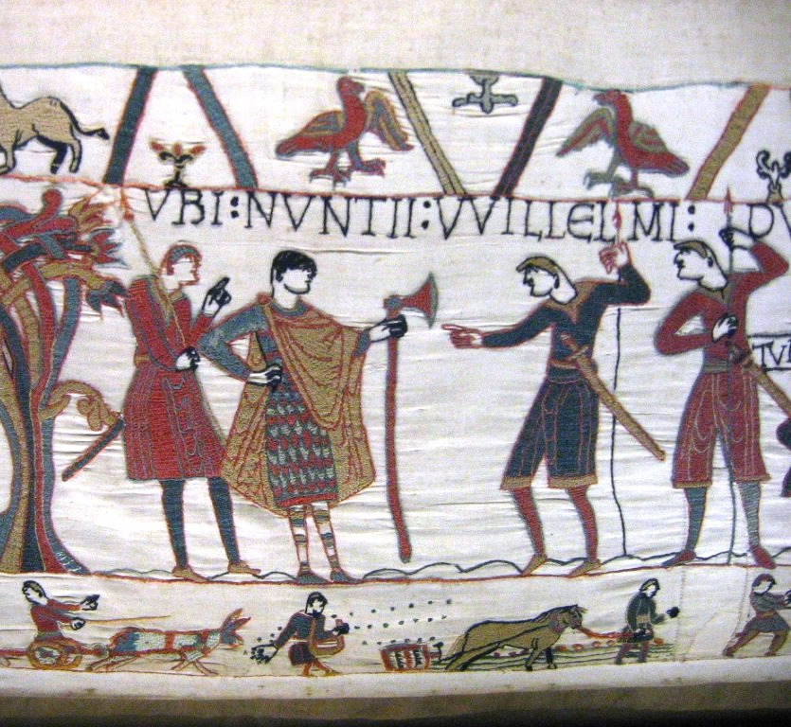Norman with dane-axe in left hand
(Bayeux Tapestry)

Two-handed fighting

Left-handed fighting or two-handed fighting is mentioned three times in the OT. All three times in connection with the tribe of Benjamin. The fourth mention (NT) of weapons in the right and left hand is from the Benjamite Paul (2Cor 6:7).
The Vikings trained in two-handed offensive fighting. They had a short axe, but also the two-handed long dane-axe. They had normal spears, but also two-handed long spears. With these axes and spears they could stay out of reach of their opponents.

Tactical withdrawal ...

The Vikings were specialised in hit-and-run attacks. With their berserkers and with their surprise attacks, they were well prepared to attack unexpectedly, but the moment they were to get huge opposition, they would have to fall back onto defendable positions. Often that was a hill nearby. They would reorganize on the hill with a wall of shields. Islands are ‘hills in the sea’. Islands were often used as bases for their plunder expeditions.
In the civil war of Judges 20 the 600 surviving Benjamites withdrew to the rock of Rimmon. Abner did the same (2Sam 2:25). A tactic the Vikings would have understood:
But Joab and Abishai went after Abner: and the sun went down when they came to the hill of Ammah, which is to the east of the road through the waste land of Geba. And the men of Benjamin came together after Abner in one band, and took their places on the top of a hill (2Sam 2:24-25).

8th Clue: Benjamin: loyalty / disloyalty

And Saul cast the javelin; for he said, I WILL SMITE DAVID EVEN TO THE WALL WITH IT. And David avoided out of his presence twice (1Sam 18:11).
And Saul spoke to Jonathan his son and to all his servants, that they should kill David. But JONATHAN, SAUL’S SON, DELIGHTED MUCH IN DAVID (1Sam 19:1, RSV).
Then Saul’s anger was kindled against Jonathan, and he said unto him, Thou son of the perverse rebellious woman, DO NOT I KNOW THAT THOU HAST CHOSEN THE SON OF JESSE TO THINE OWN CONFUSION, and unto the confusion of thy mother’s nakedness? (1Sam 20:30)
AND SAUL CAST A JAVELIN AT HIM TO SMITE [JONATHAN]: whereby Jonathan knew that it was determined of his father to slay David (1Sam 20:33).
And ... there was war between the house of Saul and the house of David, that Abner made himself strong for the house of Saul. And Saul had a concubine, whose name was Rizpah ... and Ishbosheth said to Abner, Wherefore hast thou gone in unto my father’s concubine? Then was Abner very wroth ... and said, Am I a dog’s head ... So do God to Abner ... as the LORD hath sworn to David, even so I do to him; TO TRANSLATE THE KINGDOM FROM THE HOUSE OF SAUL, AND TO SET UP THE THRONE OF DAVID OVER ISRAEL ... he could not answer Abner ... because he feared him. And Abner sent messengers to David ... saying ... Make thy league with me ... my hand shall ... bring about all Israel unto thee (2Sam 3).

Shifting loyalties

Saul, Michal, Ishbosheth, Mephibosheth (2Sam 16), Jonathan, Abner,Shimei (2Sam 16), Baanah & Rechab (2Sam 4), Sheba (2Sam 20) and Paul, are all Benjamites. What they have in common is that, either they changed sides, or they became disloyal.
David was an army commander of Saul, but Saul tried to kill him again and again. Jonathan and Michal loved David and chose his side, against their father Saul.
Abner fought a civil war for years against Joab (David) for Saul’s son Ishbosheth. However the moment Ishbosheth admonished Abner over his father’s concubine, Abner turned against his boss and went to David to hand over the north to him.
Ishbosheth had warbands fighting for him with two Benjamite brothers, Baanah and Rechab. They betrayed the king they were fighting for and killed Ishbosheth during his sleep, decapitated him and took the head to David (hoping for a reward).
Shimei turned against his fleeing king David and threw stones at him. The Benjamite Sheba called (in vain) for rebellion against the House of David.
Saul / Paul first persecuted the Church, was converted and ended up fighting for the Church (Acts of the Apostles).

Selfish Viking Individualism
https://norse-mythology.org/the-vikings-selfish-individualism/

There’s a common Romantic image of the Vikings fighting their wars for the collective well-being of their nations and homelands, putting tribal loyalty above self-interest. That image could hardly be further from the historical reality. The Vikings weren’t dutiful soldiers selflessly sacrificing themselves for their people; they were mercenaries who, when it really came down to it, cared first and foremost for their own selfish gain. ...
Individual warriors chose which warband they wanted to join – subject to the chieftain’s approval, of course – and could leave and join another at any time. The warriors exchanged their services for a share of whatever spoils were obtained in battle. ...
The Viking style of warfare was therefore based on the freedom of the individual warrior to strive to outdo his peers, rather than just marching in lockstep with others. Indeed, it was fairly common for members of the same warband to challenge each other to single combat to the death over a dispute about whose deeds were greater – especially at feasts in which large quantities of alcohol were consumed. ...
When a warrior vowed loyalty to his lord, he became not so much his servant as his voluntary companion. ...
The targets of Viking attacks were commonly other groups of Vikings. But they didn’t stop there. They frequently captured other Vikings and sold them into slavery, just as they would foreigners captured in battle. They seem to have made little if any distinction in this regard between Vikings and non-Vikings, pagans and Christians, etc.

9th Clue: Benjamin: kingdom builders

Then Samuel took the bottle of oil, and put the oil on his head and gave him a kiss and said, Is not the Lord with the holy oil MAKING YOU RULER OVER ISRAEL, HIS PEOPLE? ... (1Sam 10:1a).
And the spirit of God came mightily upon Saul when he heard these words, and his anger was greatly kindled. He took a yoke of oxen, and cut them in pieces and sent them throughout all the territory of Israel by the hand of messengers, saying, "Whoever does not come out after Saul and Samuel, so shall it be done to his oxen!" Then the dread of the LORD fell upon the people, and they came out as one man (1Sam 11:6-7).
Now when Saul had taken HIS PLACE AS RULER OF ISRAEL, he made war on those who were against him on every side, Moab and the Ammonites and Edom and the kings of Zobah and the Philistines: and WHICHEVER WAY HE WENT, HE OVERCAME THEM (1Sam 14:47, BBE).
While they were worshiping the Lord and fasting, the Holy Spirit said, "Set apart for me Barnabas and Saul for the work to which I have called them." (Acts 13:2, RSV).
And count the forbearance of our Lord as salvation. SO ALSO OUR BELOVED BROTHER PAUL WROTE TO YOU ACCORDING TO THE WISDOM GIVEN HIM, SPEAKING OF THIS AS HE DOES IN ALL HIS LETTERS. THERE ARE SOME THINGS IN THEM HARD TO UNDERSTAND, which the ignorant and unstable twist to their own destruction ... (2Pe 3:15-16, RSV).

Saul of the OT & Saul of the NT

Benjamites are good organizers and kingdom builders. At the time of the judges Israel was a loose confederation of tribes. There was no central governance, no king. God used the Benjamite Saul to build the kingdom, which was later taken over by the House of David.
The church is a spiritual kingdom: But you are A CHOSEN RACE, A ROYAL PRIESTHOOD, A HOLY NATION, GOD’S OWN PEOPLE, that you may declare the wonderful deeds of him who called you out of darkness into his marvelous light (1 Pe 2:9).
The Messianic Jewish branch of the Church soon became extinct. It was the Greek branch of the Church that lasted and that spread over the world. Especially Paul was instrumental in building that Church with his missionary journeys and his epistles. Paul wrote 13 of the 26 NT books. Paul was an able organizer and he was of the tribe of Benjamin.

Vikings – organizers & kingdom builders

Vikings were not just plunderers in hit-and-run actions, but also good organizers. Otherwise they would never have been able to make these long journeys. The Danish Vikings plundered the coasts of Frisia and Frankish State. They rowed around Spain and plundered Lyon and the Roman State.Vikings from Norway founded colonies on Iceland, Greenland and New Foundland (Canada).
The Danish kings changed Denmark into a close kingdom and had ingenious ring fortresses built, like Trelleborg (see below).

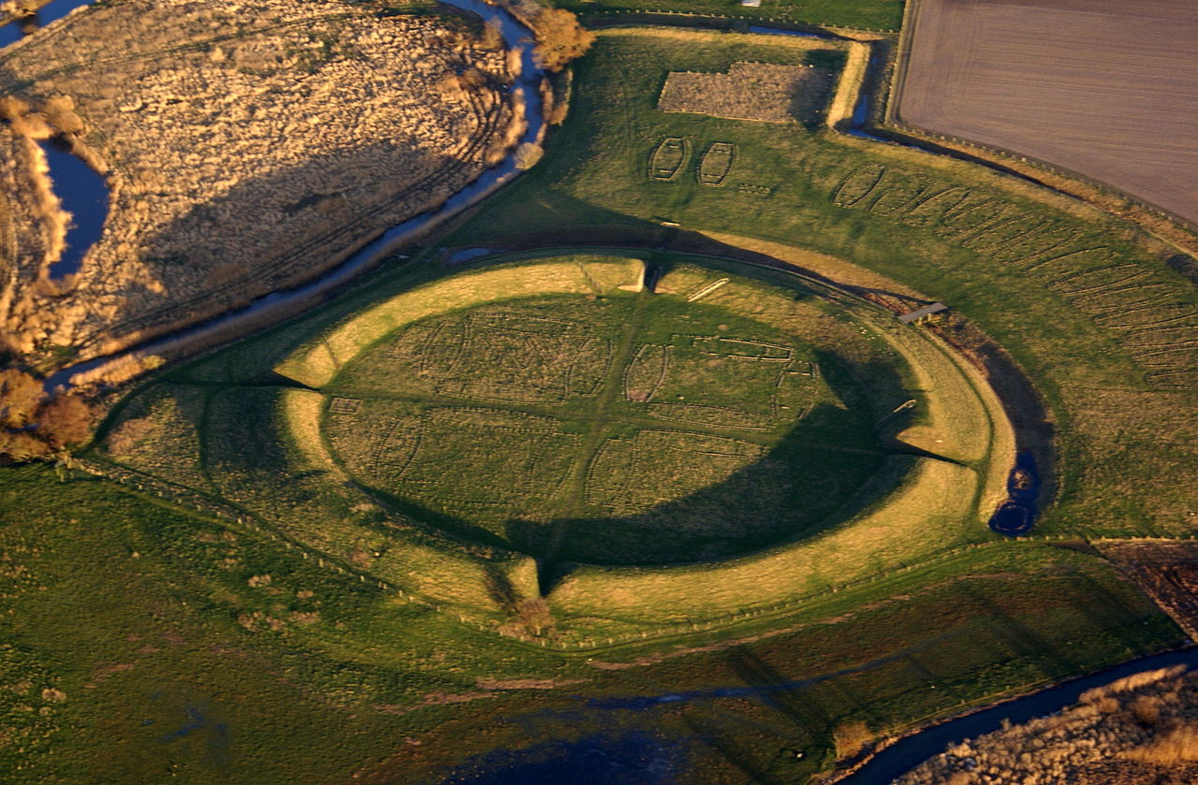

The Danes also captured and colonized eastern England, the so-called Danelaw. Danish law was enforced here. The English word ‘law’ is from the Danish ‘lag’.
There were 7 Anglo-Saxon kingdoms. The first king of a united England was a Dane, Canute the Great (995-1035). He was king of England, Denmark and Norway.
The Danish Vikings also settled in Normandy. The Normans were formidable warriors, good organizers and kingdom builders. In 1066 AD they conquered England. They were dominant in the First Crusade, which resulted in a string of Norman Kingdoms on the map of Europe: England, Normandy, Sicily, Cyprus and Antioch.
Benjamites (Vikings) are good organizers and kindom builders. The Scandinavian kingdoms today are well organized states.
10th Clue: Benjamin: love / social

Benjamin is a ... wolf ... (Gen 49:27a).
And of Benjamin [Moses] said, The beloved of the LORD shall dwell in safety by him; and the LORD shall cover him all the day long ... (Dt 33:12).
And it came to pass, when he had made an end of speaking unto Saul, that the soul of Jonathan was knit with the soul of David, and JONATHAN LOVED HIM AS HIS OWN SOUL. ... Then Jonathan and David made a covenant, BECAUSE HE LOVED HIM AS HIS OWN SOUL (1Sam 18:1-3).
[Benjamin]: Do ye also, therefore, my children, LOVE THE LORD God of heaven and earth ... Fear ye the Lord, and LOVE YOUR NEIGHBOUR ... (Testament of Benjamin 3:1-3).
[Paul]: Owe no man any thing, BUT TO LOVE ONE ANOTHER: for he that loveth another hath fulfilled the law (Rom 13:8).
[Paul]: LOVE DOES NO WRONG TO A NEIGHBOR; therefore love is the fulfilling of the law (Rom 13:10, RSV).
LOVE IS patient and kind; love is not jealous or boastful; it is not arrogant or rude. Love does not insist on its own way; it is not irritable or resentful; it does not rejoice at wrong, but rejoices in the right. Love bears all things, believes all things, hopes all things, endures all things. Love never ends ... (1Corinthians 13, RSV).

Benjamin & love

Benjamin is a wolf, devouring for its prey, but wolves are social animals living in a pack. Wikipedia: The gray wolf is a social animal, whose basic social unit consists of a mated pair, accompanied by the pair's adult offspring. The average pack consists of a family of five to 11 animals (one to two adults, three to six juveniles and one to three yearlings), or sometimes two or three such families, with exceptionally large packs consisting of up to 42 wolves being known. In ideal conditions, the mated pair produces pups every year, with such offspring typically staying in the pack for 10–54 months before dispersing ...

David & Jonathan

The greatest love and loyalty of two men in the Bible were shown by the two ‘brothers-in-arms’, David and Jonathan. This love was to Jonathan’s disadvantage. He knew David would be king and that he would not. Yet that did not prevent him from loving David and protecting him from his father Saul.
House of David and Jerusalem

David looked after Mephibosheth, Jonathan’s son. Later on in history, the tribe of Benjamin sided with Rehoboam, David’s grandson. The House of David ruled from Jerusalem, a Benjamite town.

Paul, from sword to love

Paul initially persecuted the Church, but later built the Church. The Ode to Love, the Ode to Charity, 1 Corinthians 13, was written by Paul, by a Benjamite!

Vikings Christianized

The plundering during the Viking Age lasted for about three centuries. The Christianizing of the Scandinavians (9th – 12th C.) ended the Viking Age. The Vikings became Catholic and started building churches and monasteries, instead of plundering them.
In the Testament of Benjamin the patriarch Benjamin had warned his offspring for the seven evils of the sword and he also admonished them to love God and neighbour.
Swords with a large crossbar have the shape of a cross. Scandinavian countries have flags with Latin crosses; in a way these symbolize the change from sword to cross. After 1517 the Scandinavian countries became Lutheran (protestant). The dominant colours of their flags are red, white and blue, which are dominant colours in the flags of many Lost Tribes Nations.

Social legislation

Scandinavian countries are ahead in social legislation. In this they show the social side of the wolf. Less fortunate fellow countrymen are well looked after.

Development Aid

Development Aid can be measured in total aid or in a percentage of the GNP (Gross National Product). Below the Top 5 nations of given development aid in a percentage of their GNP. Norway and Denmark (descendants of the Vikings) are in the Top 5:

1. Sweden – 1.40%
2. Norway – 1.05%
3. Luxembourg – 0.93%
4. Denmark – 0.85%
5. Netherlands – 0.76%

Summer of 2019
Gouda, Holland
Bert Otten

Dan – Danes – Denmark – Irish

Because the people of Denmark call themselves Danes some writers identify them with the tribe of Dan. I think this is incorrect. We do not identify the people along the Don, Dniepr, Danube or in Donetsk or in Dantzig to be Danites. Likewise I think that Denmark is part of the trail of Dniepr, Dniester, Danube, Dantzig, Denmark. These are areas where the tribe of Dan passed through. One indication that Dan did not remain in Denmark is that there are no other toponyms of Dan to be found in Denmark. The area later gave the name to its later inhabitants. The Danites continued naming rivers and hillforts to their ancestor Dan and ended up in Ireland, where dozens of toponyms with Dun-, Don-, Din- can be found. And from there they took these toponyms to the rest of the world.
In the near future I am hoping to write Ten Prophetic Clues Concerning Dan & the Irish. It will be apparent that those 10 Danite clues cannot be applied to the Danes of Denmark and that the 10 Benjamite clues of the Vikings cannot be applied to the Irish. The Danes of Denmark did not go around e.g., marking the map with Dan-, Dun-, Don-, Din- toponyms and the Irish did not go around Europe in hit-and-run plunder raids.

